Sustainable Smart City Assistant Using IBM Granite LLM

A Project Report
submitted in partial fulfillment of the requirements
of
Generative AI with IBM Cloud
Internship
with
SMARTBRIDGE in collaboration with APSCHE
by
Padala Suguna
Team ID: LTVIP2025TMID34559
sugunapadala739@gmail.com
Institution: DMSSVH College of Engineering

Contents
- Introduction
1.1 Project Overview
1.2 Purpose
- Ideation Phase
2.1 Problem Statement
2.2 Empathy Map Canvas
2.3 Brainstorming
- Requirement Analysis
3.1 Customer Journey Map
3.2 Solution Requirement
3.3 Technology Stack
- Project Design
4.1 Problem Solution Fit
4.2 Proposed Solution
4.3 Solution Architecture
- Project Planning & Scheduling
- Functional and Performance Testing
- Results
- Advantages & Disadvantages
- Conclusion
- Future Scope
- Appendix

1. Introduction

1.1 Project Overview
The Sustainable Smart City Assistant is an innovative web application designed to empower urban planners, environmental scientists, and local government officials with advanced, data-driven tools for sustainable city management. It leverages cutting-edge AI via IBM Granite LLM, combining KPI analysis, time-series forecasting, anomaly detection, and AI chat assistance through a seamless Streamlit-FastAPI framework.

1.2 Purpose
To streamline sustainability efforts by enabling real-time KPI analysis, prediction, and eco-guided decision-making, enhancing efficiency and resilience in urban planning.

2. Ideation Phase

2.1 Problem Statement
Urban sustainability is challenged by fragmented systems, poor data usability, and lack of AI integration. This tool bridges the gap between data analytics and decision-making.

2.2 Empathy Map Canvas
Stakeholders: Urban Planners, Scientists, Officials
Say: “We need fast, insightful analysis.”
Think: “Smart tools should simplify decision-making.”
Do: Upload data, use chat assistant, generate reports.
Feel: Confused by complex data, desire clarity.

2.3 Brainstorming
- KPI uploads in CSV
- Time-series forecasts
- Chat assistant for queries
- AI news summarization (SerpAPI)
- PDF report generation with eco-friendly tips

3. Requirement Analysis

3.1 Customer Journey Map
Awareness: Discovered via GitHub/events
Engagement: Uploads data, interacts with UI
Decision: Uses reports to guide policy
Retention: Regular insights, updates

3.2 Solution Requirement
Functional:
- CSV upload, chatbot, forecasting, anomaly detection
- PDF export, AI summaries
Non-Functional:
- FastAPI backend, <2s responses, Streamlit UI
Constraints:
- No authentication, CSV file storage

3.3 Technology Stack
Frontend: Streamlit, matplotlib, seaborn
Backend: FastAPI, Python 3.11, statsmodels, SerpAPI, IBM Granite LLM
Storage: CSV, optional SQLite/MongoDB
APIs: Watsonx, SerpAPI, optional Pinecone, Google Maps

4. Project Design

4.1 Problem Solution Fit
It provides a one-stop, AI-enabled interface to guide eco-conscious city development through accurate data insights.

4.2 Proposed Solution
- Upload city KPI data
- Forecast trends and detect anomalies
- Chatbot interaction with IBM Granite
- Generate PDF reports with sustainability recommendations

4.3 Solution Architecture
See the architecture diagram 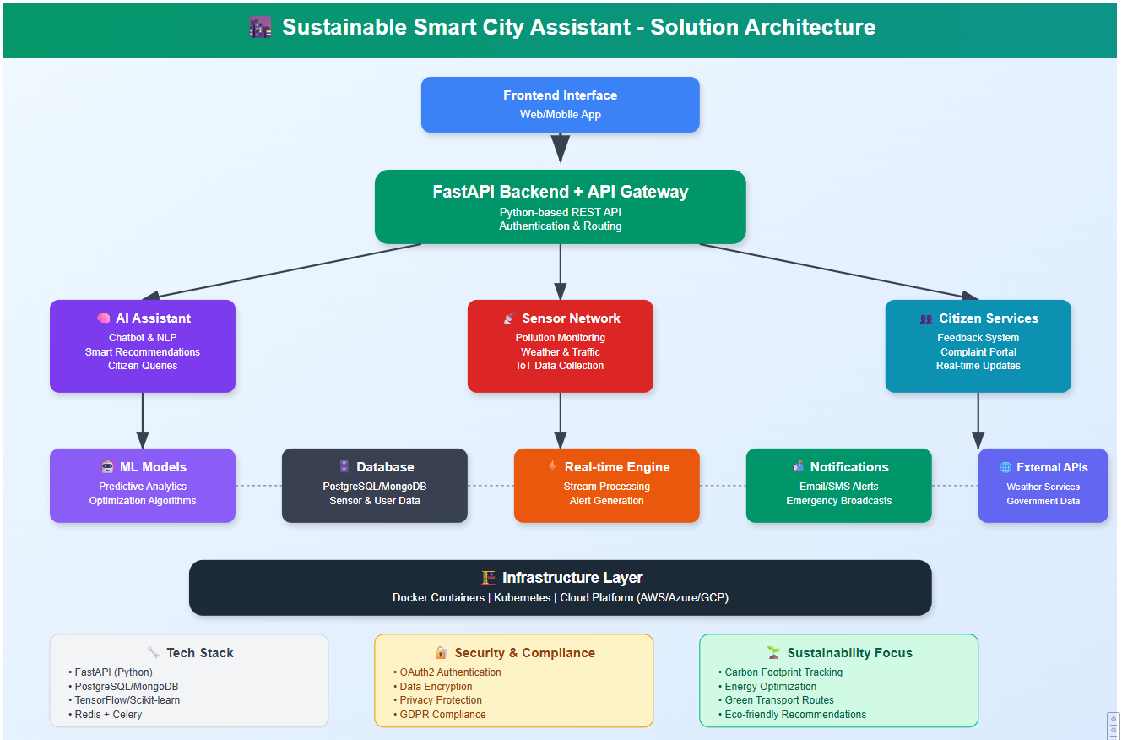

5. Project Planning & Scheduling

5.1 Project Planning
Phase 1: Chat assistant integration
Phase 2: CSV upload
Phase 3: Forecasting & anomaly logic
Phase 4: Frontend UI with Streamlit
Phase 5: Pinecone integration
Phase 6: Voice & report modules

6. Functional and Performance Testing
- Forecasting & anomaly detection validated with sample data
- Chatbot tested for urban queries
- File uploads and dashboards responsive
Performance Benchmarks:
- Chat API: <500ms
- Forecast: <2s
- News Summary: <3s

7. Results

7.1 Output Screenshots

Figure 1: Chat Assistant
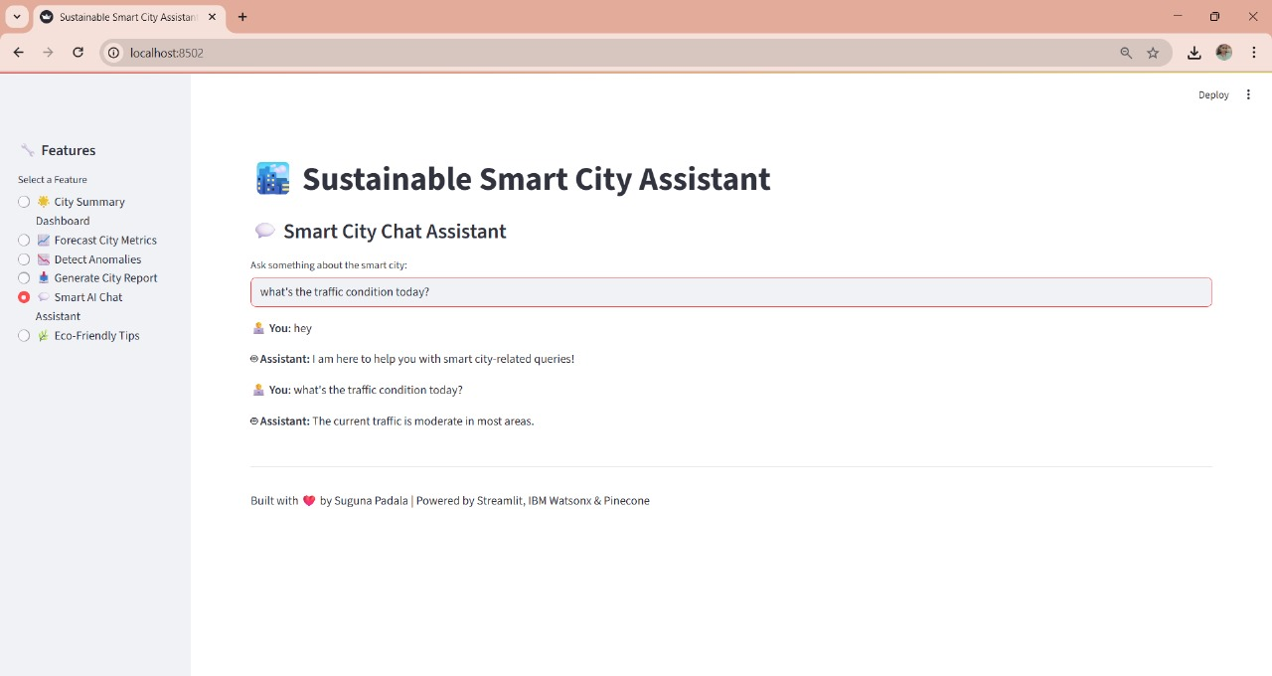

Figure 2: Report Generation
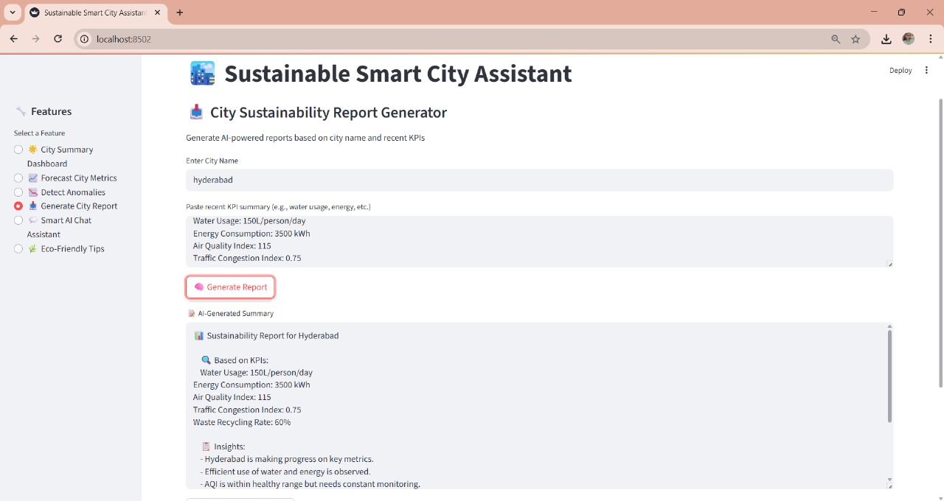
Figure 3: CSV Upload & Forecast
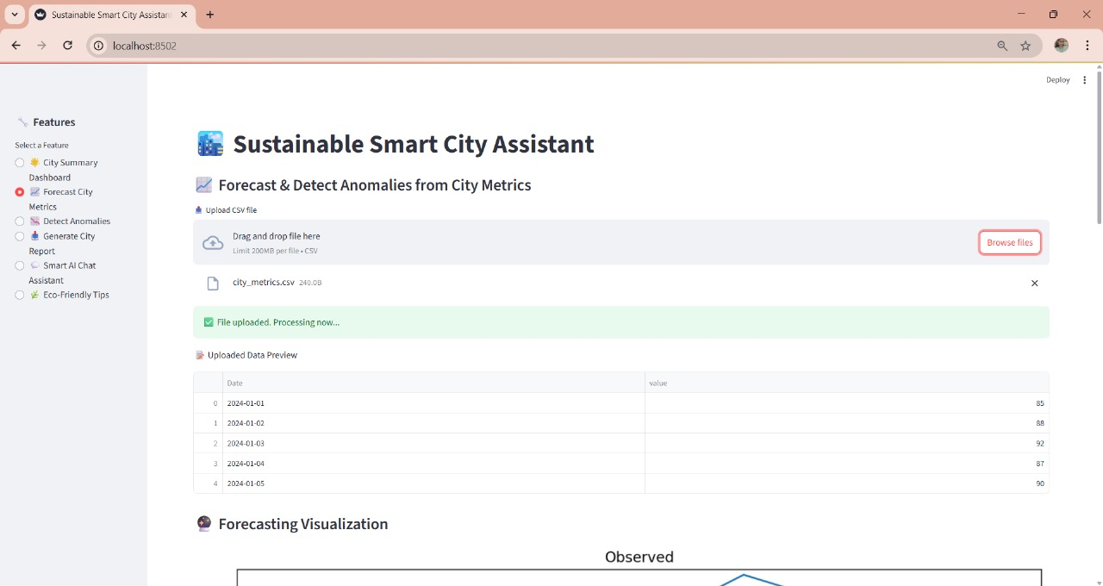

Figure 4: Anomaly Detection Graph
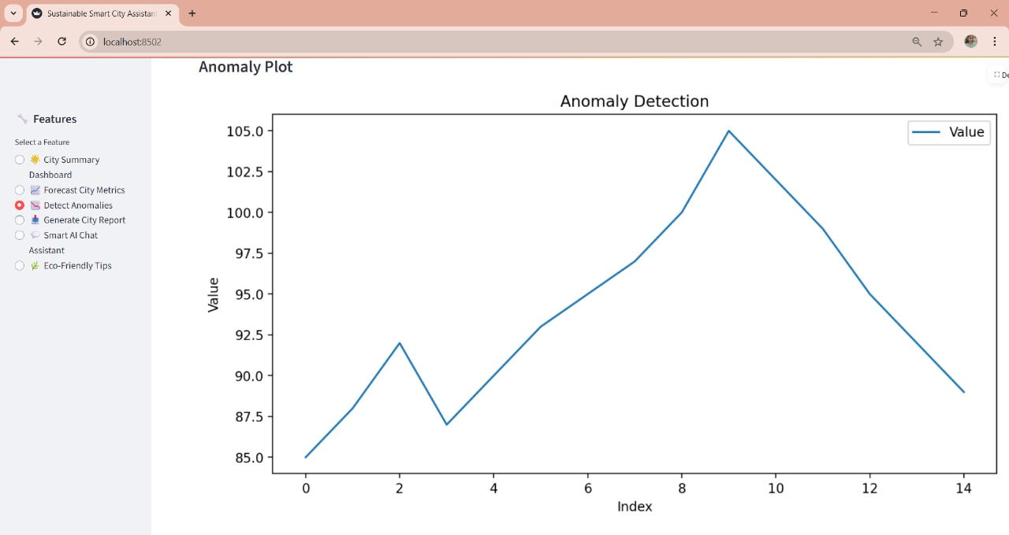
Figure 5: KPI Dashboard
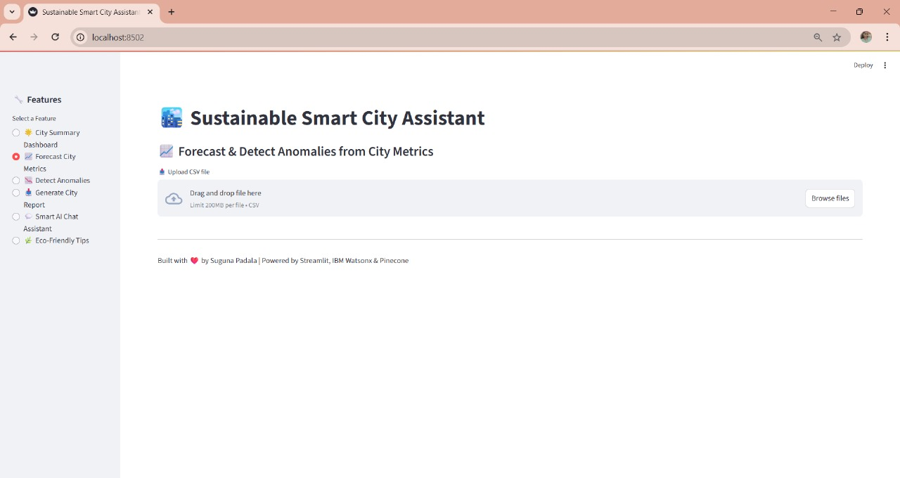

7.2 Sample Outputs
Sample Forecast:
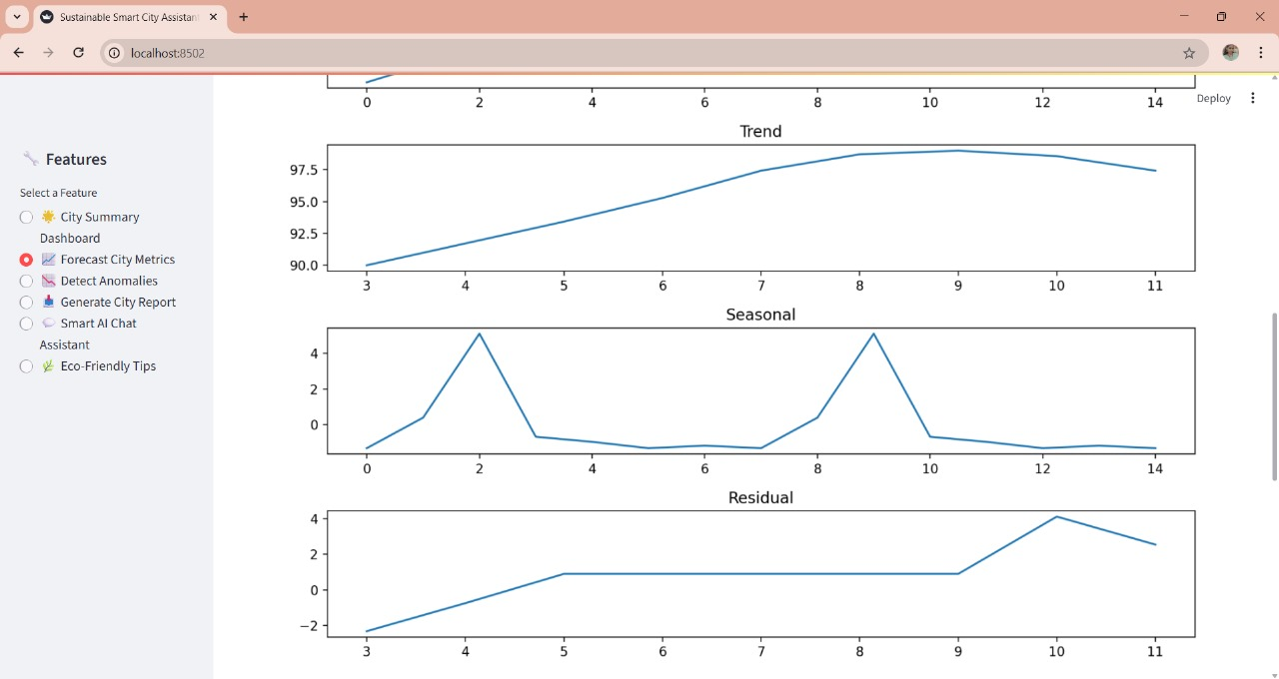

8. Advantages & Disadvantages

8.1 Advantages
- User-friendly Streamlit UI
- Modular FastAPI backend
- Real-time assistance with IBM LLM
- Extensible with future integrations

8.2 Disadvantages
- Relies on CSV, no DB by default
- No user auth or multi-role setup
- Voice/semantic features not fully implemented

9. Conclusion
The Smart City Assistant demonstrates a viable approach to sustainable city analytics using LLMs, forecasting models, and real-time tools. It meets current planning needs while offering a roadmap for scalable innovation.

10. Future Scope
- Role-based authentication (OAuth2/JWT)
- DB storage (SQLite/MongoDB)
- Real-time IoT integration
- Map route planning APIs (Google/TomTom)
- Multilingual support & voice assistant
- Domain-specific AI news curation

11. Appendix
11.1 GitHub & Project Demo Link
Project Demo Video URL
My Github Repo

